**Difference Between Test Data Management and Test**

**Environment Management**

**Test data management**

TDM is the process of fulfilling the test data needs of testing teams by ensuring that test data of the right quality is provisioned in suitable quantity, correct format and proper environment, at the appropriate time

**Test Environment Management**

A testing environment is a setup of software and hardware for the testing teams to execute test cases. In other words, it supports test execution with hardware, software and network configured.

Test bed or test environment is configured as per the need of the Application Under Test. On a few occasion, test bed could be the combination of the test environment and the test data it operates.

**Test Data Management (TDM) and Test Environment Management (TEM)** automation, enterprises can reduce build effort and errors, which will bring tangible benefits their way.

We can also help with service virtualization for effective creation and management of Test Data.

[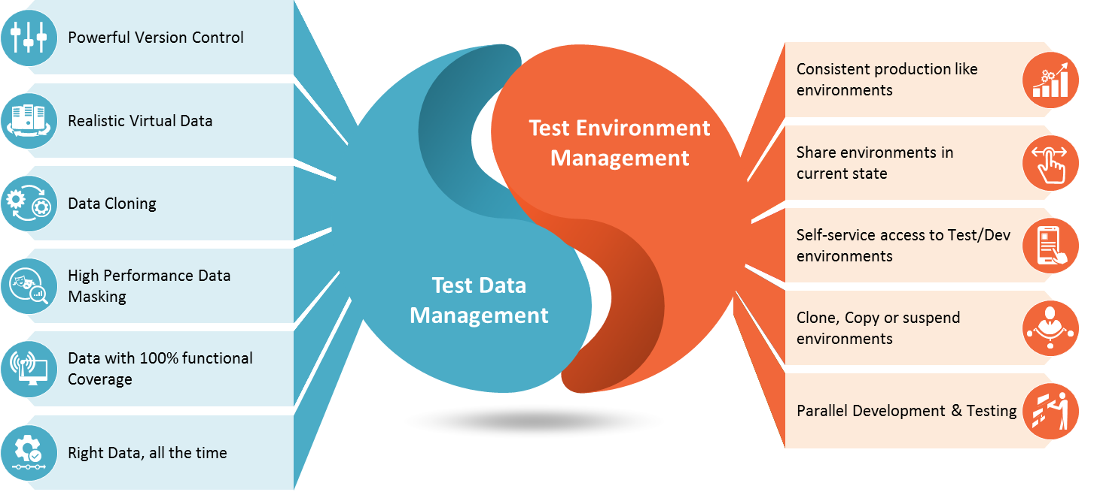](http://techarcis.com/wp-content/uploads/2017/03/tdm.png)

1.Test data refreshing and refining

2.Building, refreshing and archiving data

3.Review of data issues, test result and completeness

4.Changes in documents necessary to test

5.Test Data Management system and making accessible required test data